Store Supervisor User Guide

Team 8

**Table of Contents**

**Logging Into the System** **3**

**Product Catalogue (Store Department)** **3**

Browse product catalogue 3

Select list of stationery 4

**Supplier List** **4**

View Supplier List 4

View list of stationery supplied by a particular supplier 4

**Department Details** **5**

View Department details 5

**Purchase Orders** **6**

Find Purchase Orders 6

Purchase Order Details 7

Approve/Reject Purchase Order 7

**Store Supervisor Adjustment Voucher List** **8**

**Stationery Trend Analysis and Prediction** **9**

# 

# Logging Into the System

The system will be accessed via the below page. User is to enter the provided credentials into the username and password boxes.

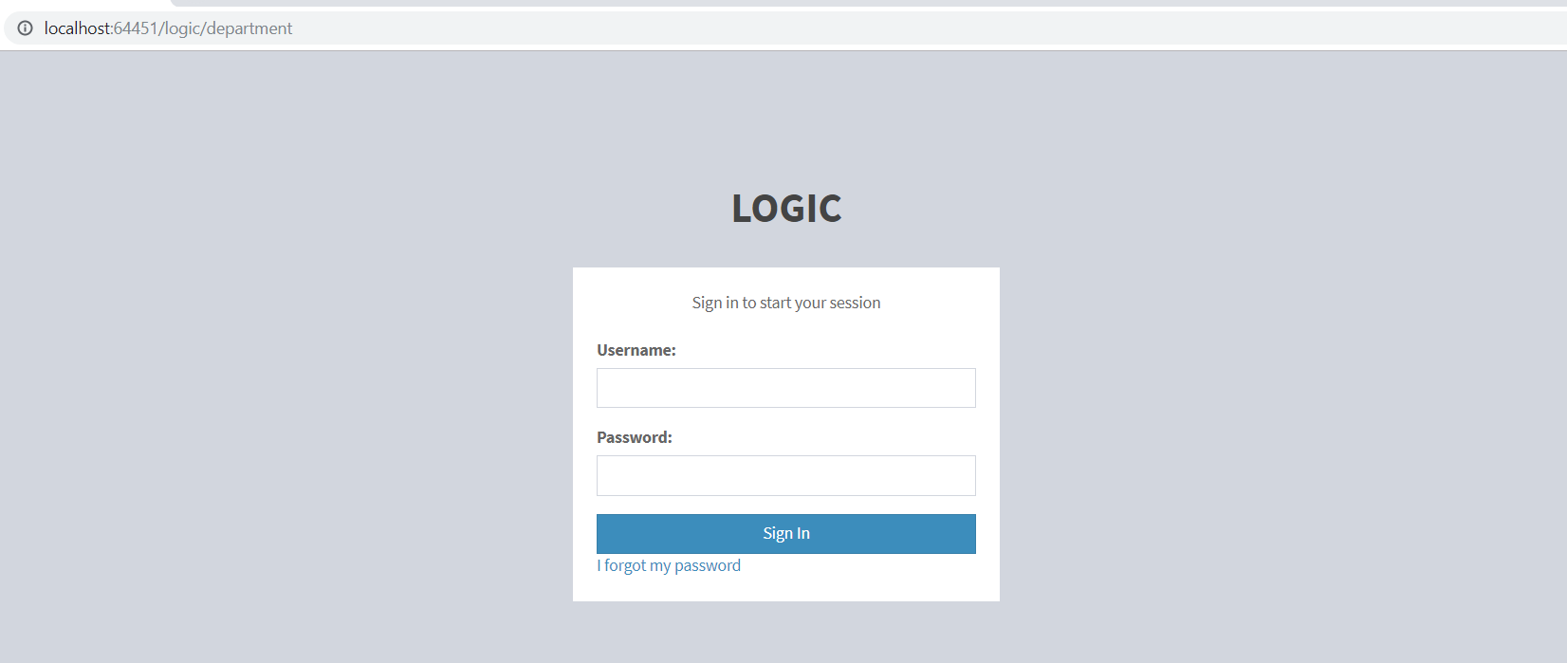

# 

# Product Catalogue (Store Department)

## Browse product catalogue

On the side bar menu, click on the ‘Product Catalogue’. It will lead to the lists of the category of the stationery.

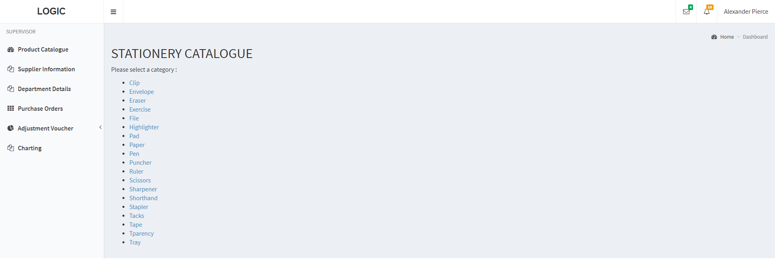

## Select list of stationery

To view the list of the stationery, click on one of the category and it will lead to the whole list of stationeries belong to that category.

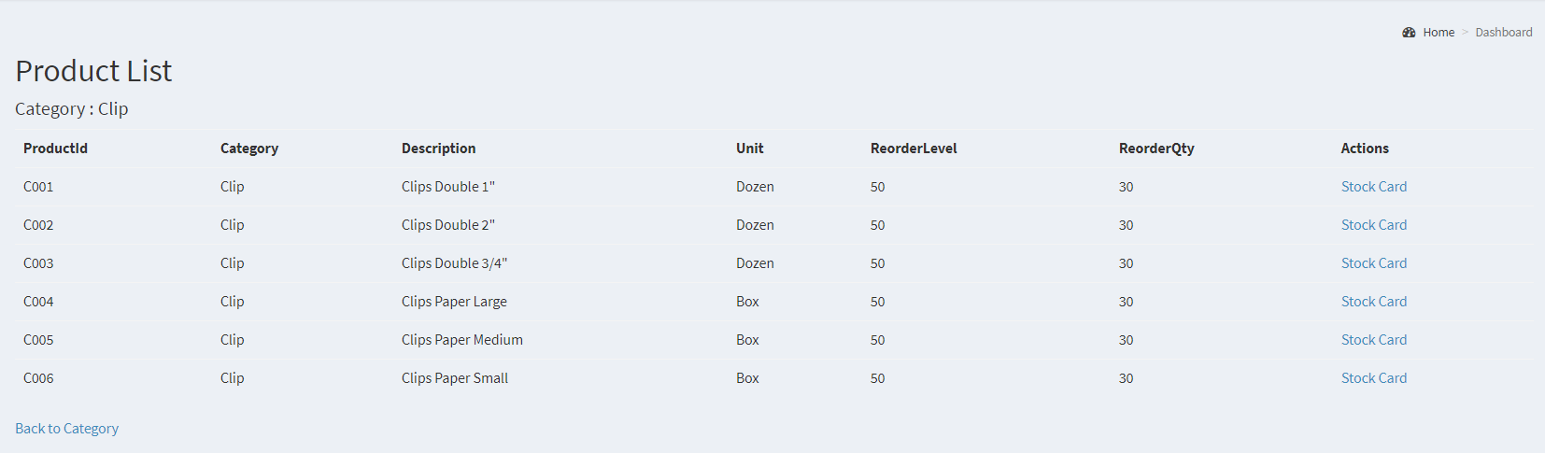

# Supplier List

## View Supplier List

User will be able to view the supplier details where it stores the information of all suppliers.

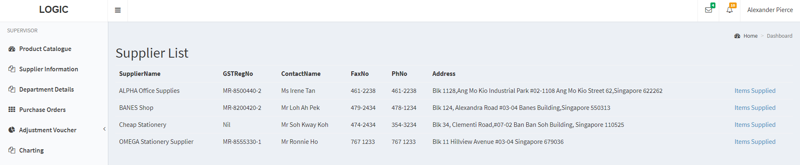

## 

## View list of stationery supplied by a particular supplier

Each supplier supplies different stationeries and user will be able to view the list of stationery provided by this supplier. User will have to click on the ‘Items supplied’ by each of the supplier to view the stationery list.

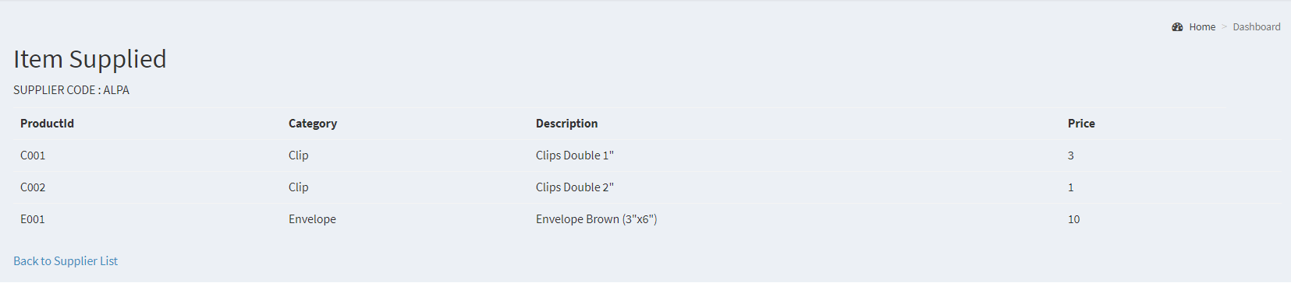

# Department Details

## View Department details

Store Clerk will be able to view the department details of Logic University. Store Clerk may also refer to the collection point of each department in case they need to refer, as well as the representative and head name of each department.

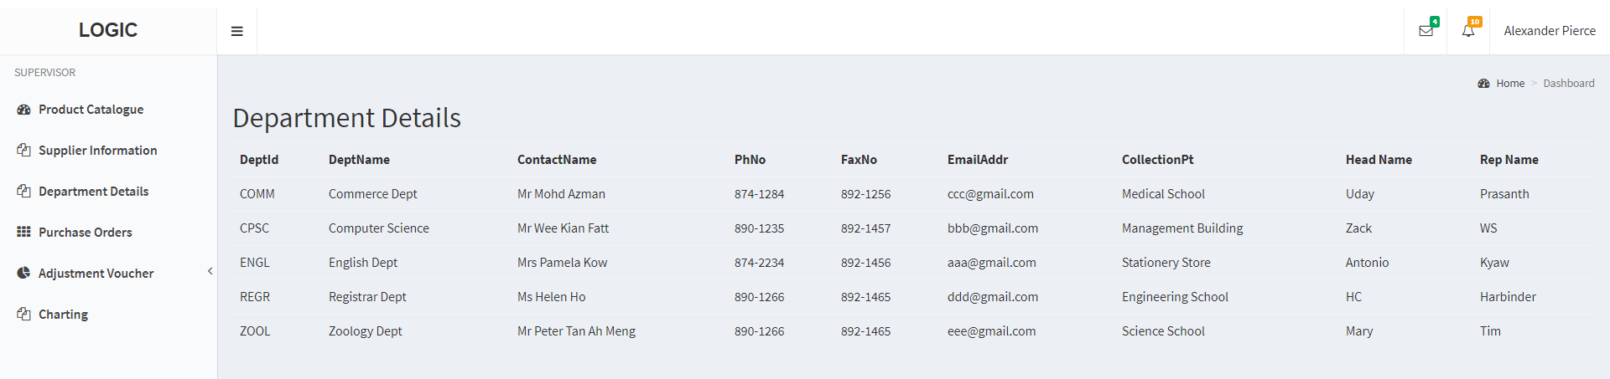

# Purchase Orders

On clicking on the link for purchase orders, the store supervisor will be brought to the following page.

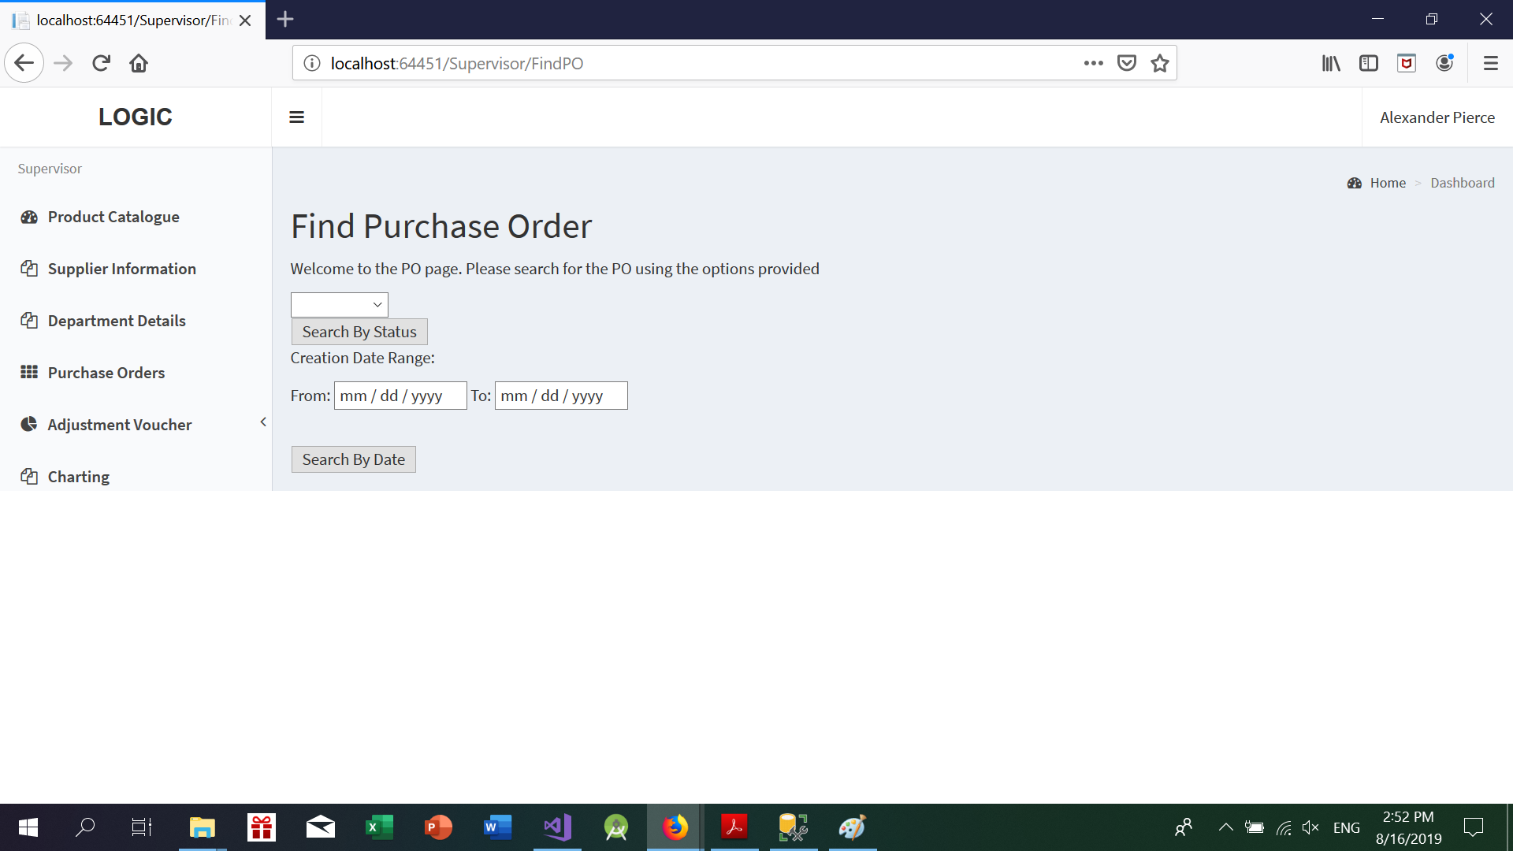

From here, the user can look for purchase orders to view or approve/reject.

## Find Purchase Orders

Search for your PO using ONE of the forms provided. The criteria the user can choose from are:

* By Date Range
* By Status (Approved, Pending, Rejected)

If any of the PO’s in the database match the search criteria, they will be displayed in the search.

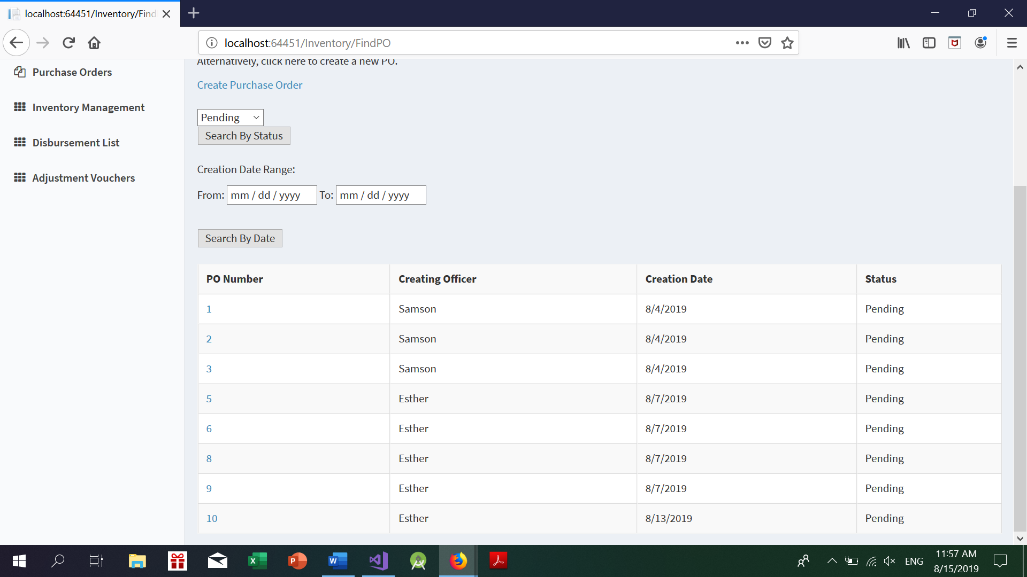

*Example of a search done by PO status*

Click on the PO number to see the specific details of the Purchase order.

## Purchase Order Details

Here is a sample of a detailed PO. (Note that the approved date only appears when the status is approved.

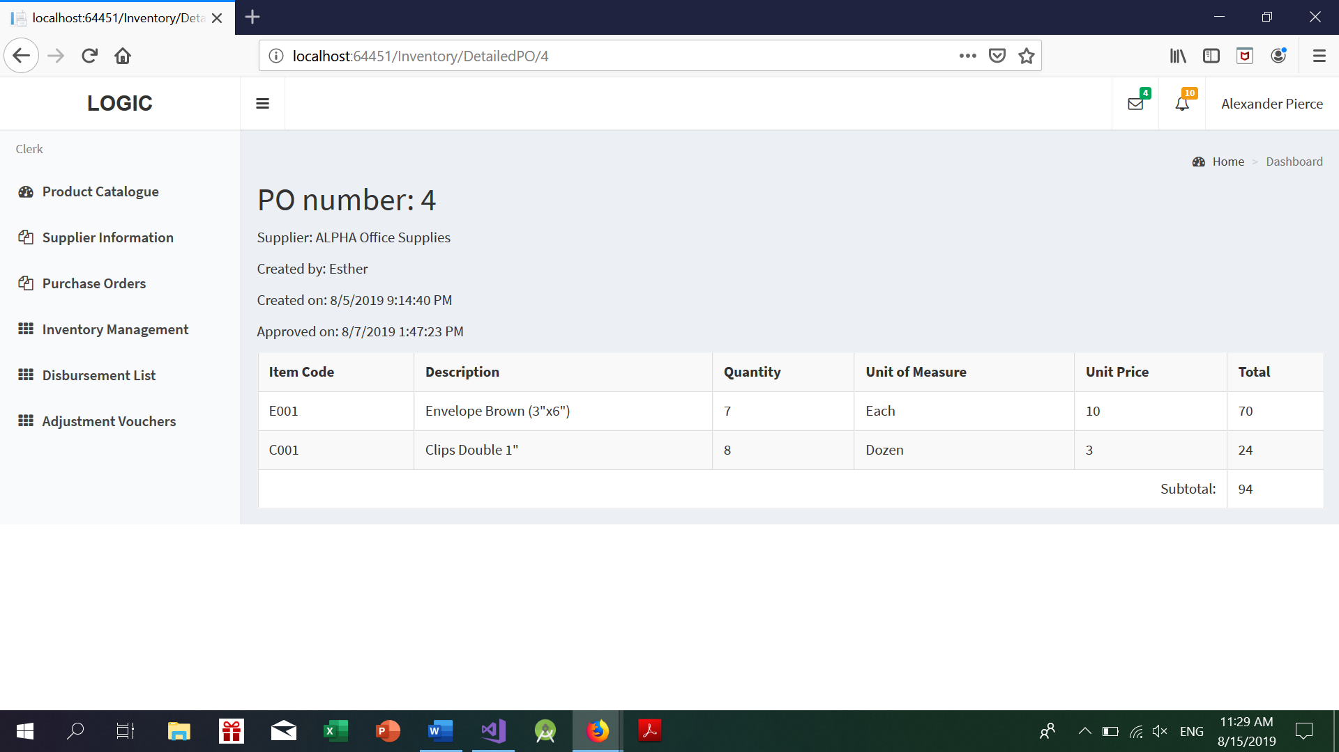

## Approve/Reject Purchase Order

If a store supervisor navigates to a PO with a “Pending Status”, he will be provided an option to Approve/Reject the PO.

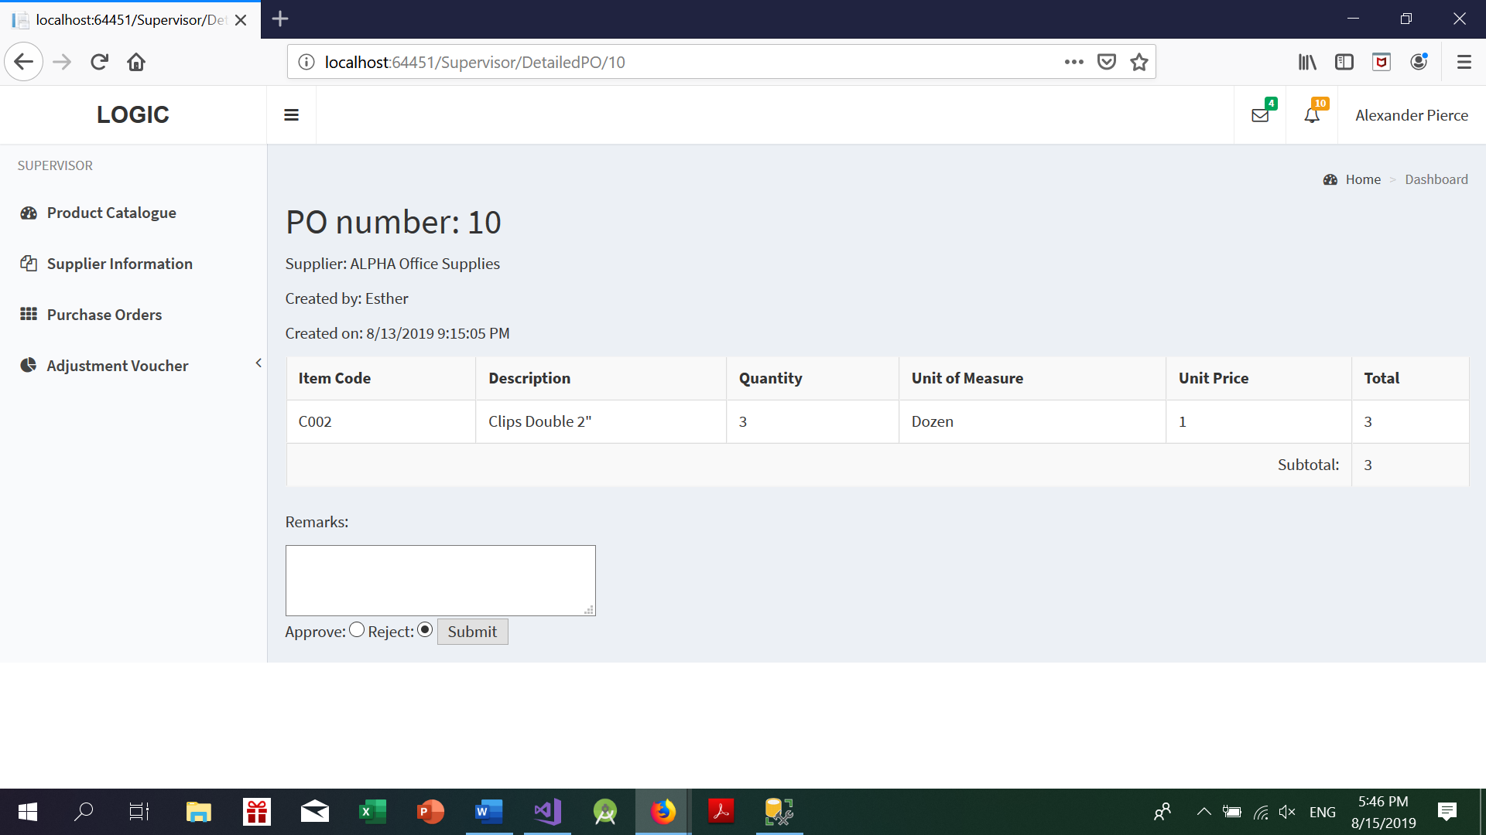

Note that if the supervisor chooses to reject the PO, the supervisor must enter the reason for rejection of the PO, otherwise he would not be able to submit the form.

## 

# Store Supervisor Adjustment Voucher List

Once the Adjustment Vouchers are submitted by the store clerk,if the total calculated price of the Adjustment Voucher is Less than $250,then the request goes to Store SuperVisor.

Once the Store supervisor logs in he can see all the requests which has adjustment amount less than $250 with status as “Pending”.The Store Supervisor can click on the pending request.

Once the supervisor clicks on the pending request it navigates to a page where the supervisor can approve or reject the request with comments.

The store supervisor can only view the Rejected or Approved requests but cannot modify.

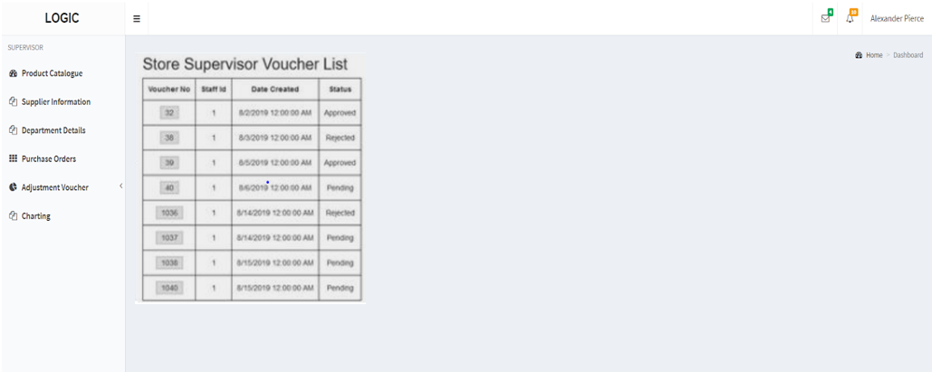

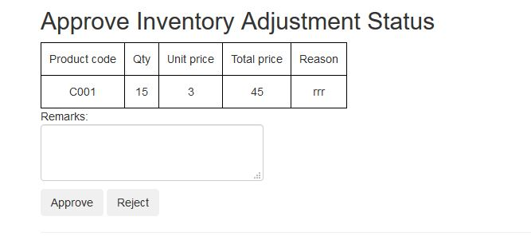

# Stationery Trend Analysis and Prediction

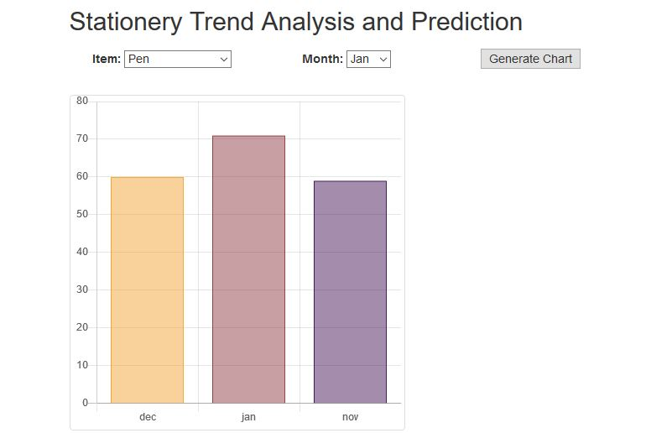

The page allows the store clerk to make predictive analysis by selecting the item category and the month. For example, if the user chooses the month, he can measure the quantity of items sold for the previous two months along with a predicted quantity for the month chosen. By checking the predicted quantity, the clerk can alter the reorder level of this particular item based on the demand. The “Generate chart” button is used to generate bar charts as per the predicted data using the previous years data as a basis for generating the model. The quantity can be viewed by hovering the mouse over the chart.